Chinook Music store
Objective Question :-
- Does any table have missing values or duplicates? If yes how would you handle it ?
Ans. :- For finding missing values in any table we use this formula
SELECT
SUM(CASE WHEN first_name IS NULL THEN 1 ELSE 0 END) AS missing_first_name,
SUM(CASE WHEN last_name IS NULL THEN 1 ELSE 0 END) AS missing_last_name,
SUM(CASE WHEN email IS NULL THEN 1 ELSE 0 END) AS missing_email,
SUM(CASE WHEN support_rep_id IS NULL THEN 1 ELSE 0 END) AS missing_support_rep
FROM customer;

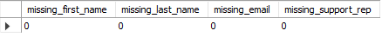
in this table there is no missing values.
For finding duplicates in any table we can find duplicates using this formula
SELECT email, COUNT(*)
FROM customer
GROUP BY email
HAVING COUNT(*) > 1;

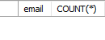
in this table there is no duplicate records.
- Find the top-selling tracks and top artist in the USA and identify their most famous genres.
Ans. :- For finding top selling tracks ,artist ,famous genre in USA we can join many table like Invoice ,Invoice_line, Track, Album, Artist, Genre together to get the result.
To get the result we write this Query:top 5 artist by total revenue
SELECT ar.name AS Artist_Name,
SUM(il.unit_price * il.quantity) AS Total_Revenue,
COUNT(DISTINCT t.track_id) AS Number_of_Tracks_Sold
FROM artist ar
JOIN album a ON ar.artist_id = a.artist_id
JOIN track t ON a.album_id = t.album_id
JOIN invoice_line il ON t.track_id = il.track_id
GROUP BY ar.artist_id, ar.name
ORDER BY Total_Revenue DESC
LIMIT 5;
Top 5 tracks by revenue:
SELECT t.name AS Track_Name,
a.title AS Album_Title,
ar.name AS Artist_Name,
SUM(il.unit_price * il.quantity) AS Total_Revenue
FROM invoice_line il
JOIN track t ON il.track_id = t.track_id
JOIN album a ON t.album_id = a.album_id
JOIN artist ar ON a.artist_id = ar.artist_id
GROUP BY t.track_id, t.name, a.title, ar.name
ORDER BY Total_Revenue DESC
LIMIT 5;
After using this Query we get the top five most selling Tracks, Artist and Genre
Top 5 artist by sales
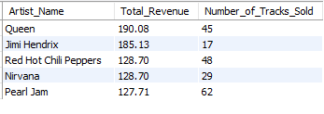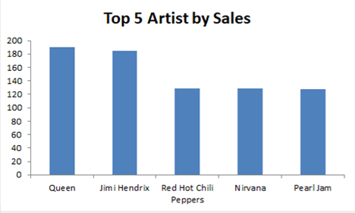
Top 5 tracks by sales
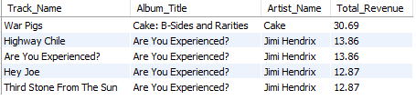
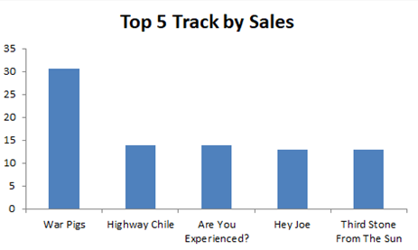
Approach:
• Identify revenue metric → Top selling is calculated using SUM(unit_price * quantity) from invoice_line.
• Start from the sales table → Use invoice_line as the base because it contains all purchase details.
• Join related tables → Connect track, album, artist, and genre to link sales with music details.
• Group by the required entity → Group by artist/track/genre to calculate total revenue for each.
• Sort and limit → Order by revenue in descending order and use LIMIT 5 to get the top results.

- What is the customer demographic breakdown (age, gender, location) of Chinook's customer base?
Ans. :- In this question we only get location for this I have write the Query like that
SELECT customer_id, first_name, last_name,
CONCAT(
COALESCE(country, ''),
',',
COALESCE(state, ''),
',',
COALESCE(city, '')) AS location
FROM customer;
We can’t get the age and gender because the table has not that demographic attributes so we can’t figure that. Overview like this
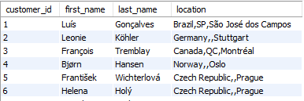
Approach:
• Identify available demographic fields
- Check the customer table for attributes like age, gender, and location.
Recognize data limitations
- Age and gender are not present, so they cannot be analyzed.
Focus on available demographic dimension: Location
- Use country, state, and city to understand geographic distribution.
Write a query to extract location details per customer
- Combine country, state, city using CONCAT() or COALESCE().
Use this data for further breakdown
- Group by country/state/city to identify major customer regions.

- Calculate the total revenue and number of invoices for each country, state, and city:
Ans. :- To calculate the total revenue and number of invoices for each country , state and city. We get the result from Invoice table . To find the result I have right the query.
SELECT billing_country, billing_state, billing_city,
COUNT(*) AS num_invoices,
SUM(total) AS total_revenue
FROM invoice
GROUP BY billing_country, billing_state, billing_city
ORDER BY total_revenue DESC;
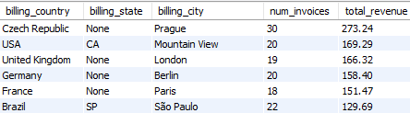
Approach:
Identify the source of revenue data
  - The invoice table contains both the invoice total and billing location.
Select relevant geographical fields
  - Use billing_country, billing_state, and billing_city to break revenue by location.
Use aggregation functions
  - COUNT(*) to get number of invoices per location
  - SUM(total) to get revenue generated from those invoices
Group by location hierarchy
  - GROUP BY billing_country, billing_state, billing_city
Sort to find highest revenue areas
  - ORDER BY total_revenue DESC to identify top-performing regions.
- Find the top 5 customers by total revenue in each country.
Ans. :- To find the top 5 customer by total revenue in each country I have join tables. Customer and Invoice . After join this two tables together I have right the query like that
SELECT customer_id, country, total_revenue
FROM (
SELECT c.customer_id, i.billing_country AS country,
SUM(i.total) AS total_revenue,
RANK() OVER (PARTITION BY i.billing_country ORDER BY SUM(i.total) DESC) AS rnk
FROM customer c
JOIN invoice i ON c.customer_id = i.customer_id
GROUP BY c.customer_id, i.billing_country
) ranked
WHERE rnk <= 5;
After running this query in editor we get the output like that:

customer_id | country | total_revenue
56 | Argentina | 39.6
55 | Australia | 81.18
7 | Austria | 69.3
8 | Belgium | 60.39
1 | Brazil | 108.9
13 | Brazil | 106.92
12 | Brazil | 82.17
11 | Brazil | 69.3
10 | Brazil | 60.39
3 | Canada | 99.99
30 | Canada | 91.08
33 | Canada | 75.24
32 | Canada | 70.29
15 | Canada | 66.33
57 | Chile | 97.02
5 | Czech Republic | 144.54
6 | Czech Republic | 128.7
9 | Denmark | 37.62
44 | Finland | 79.2
42 | France | 99.99
39 | France | 79.2
43 | France | 73.26
40 | France | 72.27
41 | France | 64.35
37 | Germany | 94.05
36 | Germany | 85.14
2 | Germany | 82.17
38 | Germany | 73.26
45 | Hungary | 78.21
58 | India | 111.87
59 | India | 71.28
46 | Ireland | 114.84
47 | Italy | 50.49
48 | Netherlands | 65.34
4 | Norway | 72.27
49 | Poland | 76.23
34 | Portugal | 102.96
35 | Portugal | 82.17
50 | Spain | 98.01
51 | Sweden | 75.24
53 | United Kingdom | 98.01
54 | United Kingdom | 79.2
52 | United Kingdom | 68.31
17 | USA | 98.01
20 | USA | 95.04
22 | USA | 92.07
21 | USA | 91.08
26 | USA | 86.13
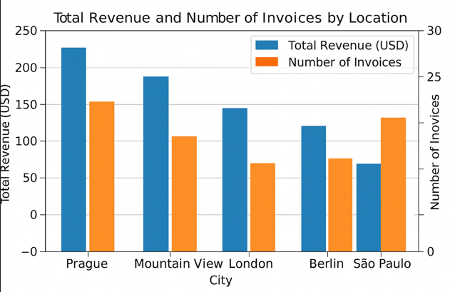
Approach:
Identify required tables
- Revenue comes from invoice.total
- Customer details come from customer
Join customer with invoice
- Join on customer_id to associate each invoice with the correct customer.
Aggregate revenue per customer per country
- Use SUM(i.total) and group by customer_id and billing_country.
Rank customers within each country
- Use RANK() OVER (PARTITION BY billing_country ORDER BY total DESC) to rank customers inside each country separately.
Filter top 5
- Select only rows where rank ≤ 5 to get top 5 customers per country.

- Identify the top-selling track for each customer.
Ans. :- To find the top-selling track for each country we have to combine some tables like Customer, Invoice, Track, Invoice_Line. After this I have write the Query :
SELECT customer_id, track_name, total_sales
FROM (
SELECT c.customer_id,
t.name AS track_name,
SUM(il.unit_price * il.quantity) AS total_sales,
RANK() OVER (PARTITION BY c.customer_id
ORDER BY SUM(il.unit_price * il.quantity) DESC
) AS rnk
FROM customer c
JOIN invoice i ON c.customer_id = i.customer_id
JOIN invoice_line il ON i.invoice_id = il.invoice_id
JOIN track t ON il.track_id = t.track_id
GROUP BY c.customer_id, t.track_id
) ranked WHERE rnk = 1;
After running this query in editor we get the output like that :
customer_id | track_name | total_sales
1 | Put Your Lights On | 0.99
2 | Cochise | 0.99
3 | Sting Me | 1.98
4 | Welcome to the Jungle | 0.99
5 | It Was A Very Good Year | 0.99
6 | Foxy Lady | 0.99
7 | Lady Double Dealer | 0.99
8 | I Wish It Would Rain | 0.99
9 | Put The Finger On You | 0.99
10 | Like A Bird | 1.98
11 | The Day I Tried To Live | 0.99
12 | Love And Marriage | 1.98
13 | 24 Caprices, Op. 1, No. 24, for Solo Violin, in A Minor | 1.98
14 | Us And Them | 0.99
15 | Hell Ain't A Bad Place To Be | 0.99
16 | Too Young To Die | 0.99
17 | Que PaÃs Ã‰ Este | 0.99
18 | Right Next Door to Hell | 0.99
19 | Spank Thru | 0.99
20 | I Like Dirt | 0.99
21 | Foxy Lady | 0.99
22 | Alberta | 0.99
23 | Whatsername | 0.99
24 | See You | 0.99
25 | Corduroy | 0.99
26 | Wherever I Lay My Hat | 0.99
27 | Little Dreamer | 0.99
28 | Get What You Need | 1.98
29 | Children Of The Grave | 0.99
30 | Help Yourself | 0.99
31 | Civil War | 0.99
32 | Please Please Please | 0.99
33 | Dude (Looks Like A Lady) | 0.99
34 | Train In Vain | 1.98
35 | Highway Chile | 0.99
36 | The Unnamed Feeling | 0.99
37 | Radio/Video | 1.98
38 | English Civil War | 0.99
39 | It's Electric | 0.99
40 | Black Hole Sun | 0.99
41 | Runnin' With The Devil | 0.99
42 | Journey To Arnhemland | 0.99
43 | Tease Me Please Me | 1.98
44 | Baba O'Riley | 0.99
45 | Up In Arms | 0.99
46 | N.I.B. | 1.98
47 | Give Me Novacaine | 0.99
48 | Confusion | 1.98
49 | Faceless | 1.98
50 | AtÃ© Que Enfim Encontrei VocÃª | 0.99
51 | Stairway To Heaven | 0.99
52 | Speak To Me/Breathe | 0.99
53 | For Those About To Rock (We Salute You) | 0.99
54 | Sparks Will Fly | 0.99
55 | Mother's Little Helper | 0.99
56 | My Way | 0.99
57 | Shape of Things to Come | 0.99
58 | Dirty Little Thing | 0.99
59 | Time | 0.99
Approach:
Identify the goal
- We need to find which track generated the highest revenue for each individual customer.
Locate required data
- Track purchase details come from invoice_line
- Track metadata comes from track
- Customer info comes from customer
- Invoices link customers and purchased tracks → invoice
Join all necessary tables
- customer → invoice → invoice_line → track
Aggregate revenue per track per customer
- SUM(unit_price * quantity) gives total spending by a customer on each track.
Rank tracks per customer & pick top 1
- Use RANK() OVER (PARTITION BY customer_id ORDER BY total_sales DESC)
- Filter where rank = 1 to get the top-selling track per customer
7.Are there any patterns or trends in customer purchasing behavior (e.g., frequency of purchases, preferred payment methods, average order value)?
Ans. :- Yes, there are patterns like frequency of purchase average order value. Preferred payment method is not in given schema so we can’t analyse this. We only analyse frequency of purchase and average order value and lifetime_value.
B y writing this query:
SELECT c.customer_id,
COUNT(i.invoice_id) AS purchase_frequency,
ROUND(AVG(i.total),2) AS avg_order_value,
SUM(i.total) AS lifetime_value
FROM customer c
JOIN invoice i ON c.customer_id = i.customer_id
GROUP BY c.customer_id
ORDER BY lifetime_value DESC;
After running this query in editor we get the output like that :
customer_id | purchase_frequency | avg_order_value | lifetime_value
5 | 18 | 8.03 | 144.54
6 | 12 | 10.73 | 128.7
46 | 13 | 8.83 | 114.84
58 | 13 | 8.61 | 111.87
1 | 13 | 8.38 | 108.9
13 | 15 | 7.13 | 106.92
34 | 13 | 7.92 | 102.96
3 | 9 | 11.11 | 99.99
42 | 11 | 9.09 | 99.99
53 | 11 | 8.91 | 98.01
50 | 11 | 8.91 | 98.01
17 | 12 | 8.17 | 98.01
57 | 13 | 7.46 | 97.02
20 | 12 | 7.92 | 95.04
37 | 10 | 9.41 | 94.05
22 | 12 | 7.67 | 92.07
21 | 11 | 8.28 | 91.08
30 | 13 | 7.01 | 91.08
26 | 12 | 7.18 | 86.13
36 | 11 | 7.74 | 85.14
27 | 9 | 9.35 | 84.15
12 | 11 | 7.47 | 82.17
35 | 16 | 5.14 | 82.17
2 | 11 | 7.47 | 82.17
55 | 10 | 8.12 | 81.18
39 | 9 | 8.8 | 79.2
44 | 11 | 7.2 | 79.2
18 | 8 | 9.9 | 79.2
54 | 9 | 8.8 | 79.2
45 | 10 | 7.82 | 78.21
25 | 10 | 7.62 | 76.23
49 | 10 | 7.62 | 76.23
33 | 12 | 6.27 | 75.24
51 | 10 | 7.52 | 75.24
16 | 8 | 9.28 | 74.25
38 | 9 | 8.14 | 73.26
43 | 12 | 6.11 | 73.26
4 | 9 | 8.03 | 72.27
40 | 9 | 8.03 | 72.27
28 | 10 | 7.23 | 72.27
24 | 8 | 8.91 | 71.28
59 | 8 | 8.91 | 71.28
32 | 8 | 8.79 | 70.29
11 | 10 | 6.93 | 69.3
7 | 9 | 7.7 | 69.3
52 | 8 | 8.54 | 68.31
23 | 10 | 6.63 | 66.33
15 | 9 | 7.37 | 66.33
48 | 10 | 6.53 | 65.34
41 | 9 | 7.15 | 64.35
31 | 11 | 5.67 | 62.37
8 | 7 | 8.63 | 60.39
10 | 12 | 5.03 | 60.39
19 | 9 | 6.05 | 54.45
47 | 9 | 5.61 | 50.49
29 | 4 | 10.15 | 40.59
56 | 5 | 7.92 | 39.6
9 | 10 | 3.76 | 37.62
14 | 10 | 2.97 | 29.7
Approach:
Identify which purchasing behavior metrics are available
- The schema contains frequency of purchase (number of invoices)
- Average order value (average invoice total)
- Lifetime value (sum of all purchases)
- Payment method is not available, so it cannot be analyzed
Select the relevant tables
- customer → to identify the customer
- invoice → to get order totals and count of purchases
Join tables
- Join customer with invoice using customer_id
Aggregate metrics
- COUNT(invoice_id) → purchase frequency
- AVG(total) → average order value
- SUM(total) → customer lifetime value
Rank/Order results
- Order by lifetime_value to find the most valuable customers
8. What is the customer churn rate?
Ans. :- To find the customer churn rate we have write the query using cte
WITH last_date AS (
SELECT MAX(invoice_date) AS max_date FROM invoice
),
active_customers AS (
SELECT DISTINCT c.customer_id
FROM customer c
JOIN invoice i ON c.customer_id = i.customer_id
JOIN last_date ld
WHERE i.invoice_date >= DATE_SUB(ld.max_date, INTERVAL 6 MONTH)
),
previous_customers AS (
SELECT DISTINCT c.customer_id
FROM customer c
JOIN invoice i ON c.customer_id = i.customer_id
JOIN last_date ld
WHERE i.invoice_date < DATE_SUB(ld.max_date, INTERVAL 6 MONTH)
)
SELECT
(SELECT COUNT(*) FROM previous_customers) AS previously_active,
(SELECT COUNT(*) FROM active_customers) AS still_active,
(
(SELECT COUNT(*) FROM previous_customers) -
(SELECT COUNT(*) FROM active_customers)
) * 100.0 / (SELECT COUNT(*) FROM previous_customers) AS churn_rate_percent;
After running this query in my editor get the output like that :
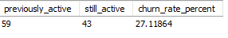
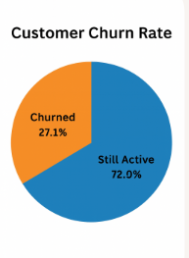
Approach:
Define time window for churn
- Customers who haven’t purchased in the last 6 months are considered “churned”.
Identify last transaction date
- Use a CTE to get the latest invoice date from the dataset.
Classify customers into 2 groups
- Active customers → purchased within the last 6 months
- Previously active customers → purchased before the last 6 months
Compare both groups
- Churn = previously active customers – still active customers
Calculate churn rate
- (churned_customers / previously_active_customers) * 100
9. Calculate the percentage of total sales contributed by each genre in the USA and identify the best-selling genres and artists.
Ans. :- To find the % total sales and each genre in USA and best-selling genres and artists we have combine many tables to get result. I have write the query using multiple tables and my query is :-
SELECT g.name AS genre_name,
a.name AS artist_name,
SUM(il.unit_price * il.quantity) AS sales,
SUM(il.unit_price * il.quantity) * 100.0 /
(SELECT SUM(il2.unit_price * il2.quantity)
FROM invoice_line il2
JOIN invoice i2 ON il2.invoice_id = i2.invoice_id
WHERE i2.billing_country = ‘USA’) AS pct_sales
FROM invoice_line il
JOIN invoice I ON il.invoice_id = i.invoice_id
JOIN track t ON il.track_id = t.track_id
JOIN album al ON t.album_id = al.album_id
JOIN artist a ON al.artist_id = a.artist_id
JOIN genre g ON t.genre_id = g.genre_id
WHERE i.billing_country = ‘USA’
GROUP BY g.name, a.name
ORDER BY pct_sales DESC;
After running this query in editor we get the output like that :-
For example I have paste some output to get the clarity:
genre_name | artist_name | sales | pct_sales
Rock | Van Halen | 42.57 | 4.0913416
Rock | The Rolling Stones | 36.63 | 3.5204567
Rock | Nirvana | 34.65 | 3.3301618
Alternative & Punk | Green Day | 31.68 | 3.0447193
Alternative & Punk | R.E.M. | 31.68 | 3.0447193
Blues | Eric Clapton | 30.69 | 2.9495718
Rock | AC/DC | 28.71 | 2.7592769
Rock | Pearl Jam | 28.71 | 2.7592769
Rock | Jimi Hendrix | 27.72 | 2.6641294
Rock | The Doors | 26.73 | 2.5689819
R&B/Soul | Marvin Gaye | 25.74 | 2.4738344
Metal | Black Sabbath | 23.76 | 2.2835395
Rock | Guns N’ Roses | 22.77 | 2.188392
Metal | System Of A Down | 21.78 | 2.0932445
Rock | Foo Fighters | 20.79 | 1.9980971
Rock | Alice In Chains | 20.79 | 1.9980971
Rock | Scorpions | 20.79 | 1.9980971
Metal | Godsmack | 19.8 | 1.9029496
Hip Hop/Rap | House Of Pain | 19.8 | 1.9029496
Approach:
Filter sales to USA only
- Since the question is specific to the USA, first restrict data to invoices where billing_country = ‘USA’.
Identify required dimensions
- Genre → from genre table
- Artist → from artist (via album → track)
- Sales → from invoice_line (unit_price * quantity)
Join all necessary tables
- invoice → invoice_line → track → album → artist → genre
Calculate total revenue per genre (and artist)
- Use SUM(unit_price * quantity) grouped by genre and artist.
Compute percentage contribution
- Divide each genre’s revenue by total USA revenue and multiply by 100.
10.Find customers who have purchased tracks from at least 3 different genres.
Ans. :- To find the result we have to combine these tables Invoice ,Invoice_line, Genre Customer and track. After combine this table I have write , the query :-
SELECT c.customer_id, c.first_name, c.last_name, COUNT(DISTINCT g.genre_id) AS genre_count
FROM customer c
JOIN invoice I ON c.customer_id = i.customer_id
JOIN invoice_line il ON i.invoice_id = il.invoice_id
JOIN track t ON il.track_id = t.track_id
JOIN genre g ON t.genre_id = g.genre_id
GROUP BY c.customer_id
HAVING COUNT(DISTINCT g.genre_id) >= 3;
After running this query we get the output like that:-
customer_id | first_name | last_name | genre_count
1 | LuÃs | GonÃ§alves | 10
2 | Leonie | KÃ¶hler | 14
3 | FranÃ§ois | Tremblay | 8
4 | BjÃ¸rn | Hansen | 9
5 | FrantiÅ¡ek | WichterlovÃ¡ | 13
6 | Helena | HolÃ½ | 11
7 | Astrid | Gruber | 8
8 | Daan | Peeters | 10
9 | Kara | Nielsen | 6
10 | Eduardo | Martins | 9
11 | Alexandre | Rocha | 8
12 | Roberto | Almeida | 8
13 | Fernanda | Ramos | 12
14 | Mark | Philips | 9
15 | Jennifer | Peterson | 6
16 | Frank | Harris | 8
17 | Jack | Smith | 12
18 | Michelle | Brooks | 12
19 | Tim | Goyer | 10
20 | Dan | Miller | 9
21 | Kathy | Chase | 10
22 | Heather | Leacock | 13
23 | John | Gordon | 12
24 | Frank | Ralston | 8
25 | Victor | Stevens | 6
26 | Richard | Cunningham | 10
27 | Patrick | Gray | 9
28 | Julia | Barnett | 12
29 | Robert | Brown | 5
30 | Edward | Francis | 13
31 | Martha | Silk | 8
32 | Aaron | Mitchell | 9
33 | Ellie | Sullivan | 11
34 | JoÃ£o | Fernandes | 10
35 | Madalena | Sampaio | 13
36 | Hannah | Schneider | 10
37 | Fynn | Zimmermann | 6
38 | Niklas | SchrÃ¶der | 12
39 | Camille | Bernard | 11
40 | Dominique | Lefebvre | 8
41 | Marc | Dubois | 12
42 | Wyatt | Girard | 12
43 | Isabelle | Mercier | 10
44 | Terhi | HÃ¤mÃ¤lÃ¤inen | 13
45 | Ladislav | KovÃ¡cs | 11
46 | Hugh | O’Reilly | 12
47 | Lucas | Mancini | 10
48 | Johannes | Van der Berg | 11
49 | StanisÅ’aw | WÃ³jcik | 9
50 | Enrique | MuÃ±oz | 11
51 | Joakim | Johansson | 9
52 | Emma | Jones | 7
53 | Phil | Hughes | 8
54 | Steve | Murray | 11
55 | Mark | Taylor | 11
56 | Diego | GutiÃ©rrez | 10
57 | Luis | Rojas | 11
58 | Manoj | Pareek | 10
59 | Puja | Srivastava | 8
Approach:
Identify the goal
- Find customers who purchased tracks from at least 3 different genres.
Locate required tables
- customer → customer info
- invoice → links customers to purchases
- invoice_line → contains purchased track info
- track → links to genre
- genre → to identify genre of each track
Join tables appropriately
- customer → invoice → invoice_line → track → genre
Aggregate by customer
- Use COUNT(DISTINCT genre_id) to find how many unique genres each customer purchased from.
Filter customers with ≥3 genres
- Use HAVING COUNT(DISTINCT genre_id) >= 3 to select only those customers.

11. Rank genres based on their sales performance in the USA.
Ans. :- To find the rank based genre and sales performance in USA we have write a query like that to get the proper value. Query:-
SELECT g.name AS genre_name,
SUM(il.unit_price * il.quantity) AS sales,
RANK() OVER (ORDER BY SUM(il.unit_price * il.quantity) DESC) AS rnk
FROM invoice_line il
JOIN invoice I ON il.invoice_id = i.invoice_id
JOIN track t ON il.track_id = t.track_id
JOIN genre g ON t.genre_id = g.genre_id
WHERE i.billing_country = ‘USA’
GROUP BY g.name;
After running this query we get the ouput like that:-
genre_name | sales | rnk
Rock | 555.39 | 1
Alternative & Punk | 128.7 | 2
Metal | 122.76 | 3
R&B/Soul | 52.47 | 4
Blues | 35.64 | 5
Alternative | 34.65 | 6
Latin | 21.78 | 7
Pop | 21.78 | 7
Hip Hop/Rap | 19.8 | 9
Jazz | 13.86 | 10
Easy Listening | 12.87 | 11
Reggae | 5.94 | 12
Electronica/Dance | 4.95 | 13
Classical | 3.96 | 14
Heavy Metal | 2.97 | 15
Soundtrack | 1.98 | 16
TV Shows | 0.99 | 17
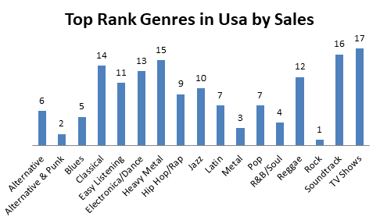
Approach:
Filter sales for USA only
- Use WHERE billing_country = 'USA' to consider only USA transactions.
Identify relevant tables
- invoice_line → contains sales amounts
- invoice → provides billing country
- track → links to genre
- genre → for genre names
Join tables
- invoice_line → invoice → track → genre
Aggregate sales per genre
- Use SUM(unit_price * quantity) grouped by genre_name to calculate total revenue per genre.
Rank genres by sales
- Use RANK() OVER (ORDER BY SUM(unit_price * quantity) DESC) to assign ranks based on total sales.

- Identify customers who have not made a purchase in the last 3 months.
Ans. To identify this we have to write a proper Query and the query is that
SELECT c.customer_id, c.first_name, c.last_name
FROM customer c
LEFT JOIN invoice i ON c.customer_id = i.customer_id
GROUP BY c.customer_id
HAVING MAX(i.invoice_date) < DATE_SUB(CURDATE(), INTERVAL 3 MONTH)
OR MAX(i.invoice_date) IS NULL;

After running this query we get the output like that
customer_id | first_name | last_name | genre_count
1 | LuÃs | GonÃ§alves | 10
2 | Leonie | KÃ¶hler | 14
3 | FranÃ§ois | Tremblay | 8
4 | BjÃ¸rn | Hansen | 9
5 | FrantiÅ¡ek | WichterlovÃ¡ | 13
6 | Helena | HolÃ½ | 11
7 | Astrid | Gruber | 8
8 | Daan | Peeters | 10
9 | Kara | Nielsen | 6
10 | Eduardo | Martins | 9
11 | Alexandre | Rocha | 8
12 | Roberto | Almeida | 8
13 | Fernanda | Ramos | 12
14 | Mark | Philips | 9
15 | Jennifer | Peterson | 6
16 | Frank | Harris | 8
17 | Jack | Smith | 12
18 | Michelle | Brooks | 12
19 | Tim | Goyer | 10
20 | Dan | Miller | 9
21 | Kathy | Chase | 10
22 | Heather | Leacock | 13
23 | John | Gordon | 12
24 | Frank | Ralston | 8
25 | Victor | Stevens | 6
26 | Richard | Cunningham | 10
27 | Patrick | Gray | 9
28 | Julia | Barnett | 12
29 | Robert | Brown | 5
30 | Edward | Francis | 13
31 | Martha | Silk | 8
32 | Aaron | Mitchell | 9
33 | Ellie | Sullivan | 11
34 | JoÃ£o | Fernandes | 10
35 | Madalena | Sampaio | 13
36 | Hannah | Schneider | 10
37 | Fynn | Zimmermann | 6
38 | Niklas | SchrÃ¶der | 12
39 | Camille | Bernard | 11
40 | Dominique | Lefebvre | 8
41 | Marc | Dubois | 12
42 | Wyatt | Girard | 12
43 | Isabelle | Mercier | 10
44 | Terhi | HÃ¤mÃ¤lÃ¤inen | 13
45 | Ladislav | KovÃ¡cs | 11
46 | Hugh | O'Reilly | 12
47 | Lucas | Mancini | 10
48 | Johannes | Van der Berg | 11
49 | StanisÅ‚aw | WÃ³jcik | 9
50 | Enrique | MuÃ±oz | 11
51 | Joakim | Johansson | 9
52 | Emma | Jones | 7
53 | Phil | Hughes | 8
54 | Steve | Murray | 11
55 | Mark | Taylor | 11
56 | Diego | GutiÃ©rrez | 10
57 | Luis | Rojas | 11
58 | Manoj | Pareek | 10
59 | Puja | Srivastava | 8

Approach:
Define inactivity period
- Customers who haven’t purchased in the last 3 months are considered inactive.
Identify required tables
- customer → for customer details
- invoice → to get purchase dates
Use a LEFT JOIN
- Join customer with invoice to include customers who may have never purchased.
Aggregate by customer
- Use MAX(invoice_date) to find the last purchase date for each customer.
Filter inactive customers
- HAVING MAX(invoice_date) < DATE_SUB(CURDATE(), INTERVAL 3 MONTH)
- Also include customers with NULL invoice dates (never purchased)

- Recommend the three albums from the new record label that should be prioritised for advertising and promotion in the USA based on genre sales analysis.
SUBJECTIVE QUESTION

Ans. :-
Query:-
SELECT
g.name AS genre_name,
ar.name AS artist_name,
al.title AS album_title,
ROUND(SUM(il.unit_price * il.quantity), 2) AS total_sales
FROM invoice_line il
JOIN invoice i ON il.invoice_id = i.invoice_id
JOIN track t ON il.track_id = t.track_id
JOIN album al ON t.album_id = al.album_id
JOIN artist ar ON al.artist_id = ar.artist_id
JOIN genre g ON t.genre_id = g.genre_id
WHERE i.billing_country = 'USA'
GROUP BY g.name, ar.name, al.title
ORDER BY total_sales DESC
LIMIT 3;
After execution the query we got the output :
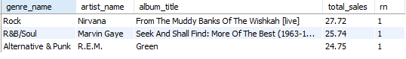
Approach:
Join Tables: Connect invoice_line → invoice → track → album → artist → genre to get all necessary details.
Filter: Restrict the data to sales in the USA (WHERE i.billing_country = 'USA').
Aggregate: Calculate total_sales using SUM(unit_price * quantity) for each album.
Group: By genre_name, artist_name, and album_title to ensure aggregation per album.
Sort & Limit: Order descending by total_sales and take the top 3 albums.

2. Determine the top-selling genres in countries other than the USA and identify any commonalities or differences.
Ans.:- We want to find out which music genres are most popular in different countries (except the USA).
Then, we can compare them with the top genres in the USA to see:
- Which genres are popular everywhere (commonalities)
- Which genres are unique to certain countries (differences)
Logic behind the Query:-
Step 1: Calculate the total sales of each genre in each country excluding USA.
Step 2: Rank genre within each country based on the total sales.
Step 3: select only top genres from each country.
Step 4: Separately calculate the top genres in the USA.
Step 5: Combine both results to easily compare global to vs. USA genre trend
Query:
WITH non_usa_genre_sales AS (
SELECT
i.billing_country,
g.name AS genre_name,
SUM(il.unit_price * il.quantity) AS total_sales
FROM invoice_line il
JOIN invoice i ON il.invoice_id = i.invoice_id
JOIN track t ON il.track_id = t.track_id
JOIN genre g ON t.genre_id = g.genre_id
WHERE i.billing_country <> 'USA'
GROUP BY i.billing_country, g.name
),
ranked_non_usa_genres AS (
SELECT
billing_country,
genre_name,
total_sales,
RANK() OVER (PARTITION BY billing_country ORDER BY total_sales DESC) AS genre_rank
FROM non_usa_genre_sales
),
top_non_usa_genres AS (
SELECT billing_country, genre_name, total_sales
FROM ranked_non_usa_genres
WHERE genre_rank = 1
),
usa_genres AS (
SELECT
g.name AS genre_name,
SUM(il.unit_price * il.quantity) AS total_sales,
RANK() OVER (ORDER BY SUM(il.unit_price * il.quantity) DESC) AS genre_rank
FROM invoice_line il
JOIN invoice i ON il.invoice_id = i.invoice_id
JOIN track t ON il.track_id = t.track_id
JOIN genre g ON t.genre_id = g.genre_id
WHERE i.billing_country = 'USA'
GROUP BY g.name
)
SELECT
'Non-USA' AS region,
billing_country AS country,
genre_name,
total_sales
FROM top_non_usa_genres
UNION ALL
SELECT
'USA' AS region,
'USA' AS country,
genre_name,
total_sales
FROM usa_genres
WHERE genre_rank <= 3
ORDER BY region, total_sales DESC;
And the output is:
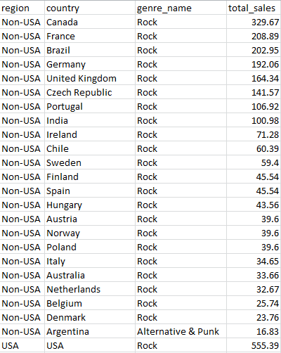

Conclusion:
The USA shows strong sales in Rock and Metal. Other countries might prefer Jazz or Latin, showing cultural differences. Rock appears as a common genre, popular both inside and outside the USA. These insights help record labels plan regional promotions and marketing more effectively.
3. Customer Purchasing Behaviour Analysis: How do the purchasing habits (frequency, basket size, spending amount) of long-term customers differ from those of new customers? What insights can these patterns provide about customer loyalty and retention strategies?
Ans.:-
Query:
WITH customer_first_purchase AS (
SELECT
c.customer_id,
MIN(i.invoice_date) AS first_purchase_date
FROM customer c
JOIN invoice i ON c.customer_id = i.customer_id
GROUP BY c.customer_id
),
customer_type AS (
SELECT
c.customer_id,
CASE
WHEN DATEDIFF(CURDATE(), f.first_purchase_date) <= 180 THEN 'New Customer'
ELSE 'Long-Term Customer'
END AS customer_category
FROM customer c
JOIN customer_first_purchase f ON c.customer_id = f.customer_id
),
customer_behavior AS (
SELECT
i.customer_id,
COUNT(DISTINCT i.invoice_id) AS total_orders, -- frequency
SUM(il.quantity) / COUNT(DISTINCT i.invoice_id) AS avg_basket_size, -- items per order
SUM(il.unit_price * il.quantity) / COUNT(DISTINCT i.invoice_id) AS avg_spend_per_order
FROM invoice i
JOIN invoice_line il ON i.invoice_id = il.invoice_id
GROUP BY i.customer_id
)
SELECT
ct.customer_category,
ROUND(AVG(cb.total_orders), 2) AS avg_order_frequency,
ROUND(AVG(cb.avg_basket_size), 2) AS avg_basket_size,
ROUND(AVG(cb.avg_spend_per_order), 2) AS avg_spending
FROM customer_behavior cb
JOIN customer_type ct ON cb.customer_id = ct.customer_id
GROUP BY ct.customer_category;
Output is:
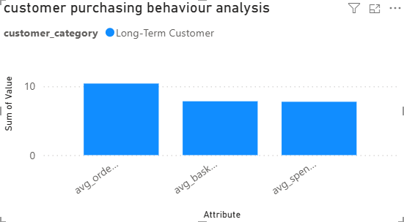
Approach:
- Identify Customer Type:Used the customer_first_purchase CTE to find the first purchase date for each customer. Categorized customers as:
    - New Customer: First purchase ≤ 6 months ago (180 days).
    - Long-Term Customer: First purchase > 6 months ago.
- Calculate Customer Behavior Metrics:total_orders: Number of invoices (order frequency). avg_basket_size: Average number of items per order. avg_spend_per_order: Average amount spent per order.
- Aggregate Metrics by Customer Category:Calculated the average of these metrics for each customer category to summarize purchasing behavior.
Insights:
High Purchase Frequency: Long-Term Customers make, on average, 10.41 orders, showing strong repeat engagement.
Moderate Basket Size: They buy ~8 items per order, indicating steady but not excessive volume per transaction.
Average Spending: Each order averages $7.76, suggesting consistent spending behavior.
Loyalty Indicator: The frequency and regular spending indicate Long-Term Customers are highly loyal and reliable for revenue.
Recommendation:
Offer loyalty programs or exclusive promotions to Long-Term Customers to maintain their engagement. Suggest complementary products or bundles to increase basket size and spending. Target these customers with tailored offers based on their purchase history. Focus on converting new customers to long-term by encouraging repeat purchases early with discounts or rewards.

4. Product Affinity Analysis: Which music genres, artists, or albums are frequently purchased together by customers? How can this information guide product recommendations and cross-selling initiatives?
Ans. :
Query:
WITH track_sales AS (
SELECT
i.invoice_id,
t.track_id,
g.name AS genre_name,
ar.name AS artist_name,
al.title AS album_title
FROM invoice_line il
JOIN invoice i ON il.invoice_id = i.invoice_id
JOIN track t ON il.track_id = t.track_id
JOIN genre g ON t.genre_id = g.genre_id
JOIN album al ON t.album_id = al.album_id
JOIN artist ar ON al.artist_id = ar.artist_id
),
genre_pairs AS (
SELECT
a.genre_name AS genre_1,
b.genre_name AS genre_2
FROM track_sales a
JOIN track_sales b
ON a.invoice_id = b.invoice_id
AND a.genre_name < b.genre_name )
SELECT
genre_1,
genre_2,
COUNT(*) AS times_bought_together
FROM genre_pairs
GROUP BY genre_1, genre_2
ORDER BY times_bought_together DESC
LIMIT 5;
Output is:
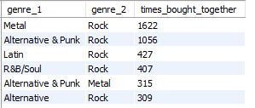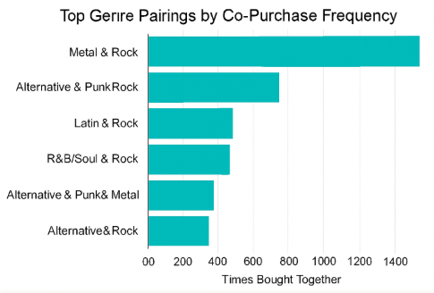
Approach:
a. The query identifies genre pairs that appear together in the same invoice, implying they were purchased in the same transaction.
b. It uses a self-join on the track_sales CTE to find combinations of genres per invoice, filtering with genre_name < genre_name to avoid duplicates and self-pairs.
c. The final aggregation counts how often each genre pair was bought together, sorted by frequency.
Insights:
• Rock appears in 5 out of 6 top combinations, indicating it's the most commonly co-purchased genre. It acts as a bridge across diverse musical tastes—from Metal to Latin and R&B/Soul.
• Alternative & Punk’s Dual Affinity This genre pairs strongly with both Rock and Metal, suggesting it appeals to fans of both mainstream and heavier music styles. It’s a versatile candidate for cross-genre playlists or bundled promotions.
• Emerging Cross-Cultural Interest Latin and R&B/Soul genres pairing with Rock hint at a growing trend of genre fusion or multicultural listening habits. This could be leveraged for global or regional marketing campaigns.
Recommendation:
• Expand to Artist/Album Level: Create similar pairings for artist_name and album_title to uncover deeper affinity patterns beyond genre.
• Segment by Customer Type or Region: Add filters or joins with customer demographics to tailor recommendations by audience segment.
• Use for Dynamic Cross-Selling: Integrate this logic into your storefront or playlist engine to suggest complementary tracks/albums during checkout or browsing.

- Regional Market Analysis: Do customer purchasing behaviours and churn rates vary across different geographic regions or store locations? How might these correlate with local demographic or economic factors?
Ans.:-
Query:
WITH last_purchase AS (
SELECT MAX(invoice_date) AS max_date FROM invoice
),
customer_stats AS (
SELECT
c.customer_id,
i.billing_country,
COUNT(DISTINCT i.invoice_id) AS total_orders,
SUM(il.unit_price * il.quantity) AS total_spent,
MAX(i.invoice_date) AS last_purchase_date
FROM customer c
JOIN invoice i ON c.customer_id = i.customer_id
JOIN invoice_line il ON i.invoice_id = il.invoice_id
GROUP BY c.customer_id, i.billing_country
),
customer_churn AS (
SELECT
cs.billing_country,
cs.customer_id,
cs.total_orders,
cs.total_spent,
CASE
WHEN cs.last_purchase_date < DATE_SUB(lp.max_date, INTERVAL 6 MONTH)
THEN 1 ELSE 0
END AS churned
FROM customer_stats cs
CROSS JOIN last_purchase lp
),
region_summary AS (
SELECT
billing_country,
COUNT(DISTINCT customer_id) AS total_customers,
ROUND(SUM(total_spent), 2) AS total_revenue,
ROUND(AVG(total_spent / total_orders), 2) AS avg_order_value,
ROUND(SUM(churned) * 100.0 / COUNT(*), 2) AS churn_rate_percent
FROM customer_churn
GROUP BY billing_country
)
SELECT
billing_country AS region,
total_customers,
total_revenue,
avg_order_value,
churn_rate_percent
FROM region_summary
ORDER BY total_revenue DESC;
Output is:
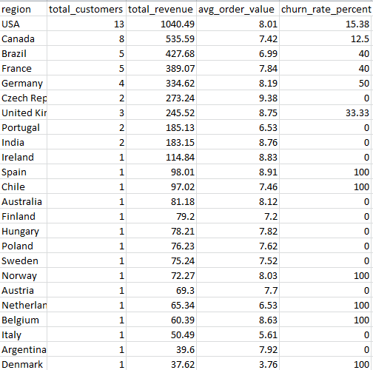
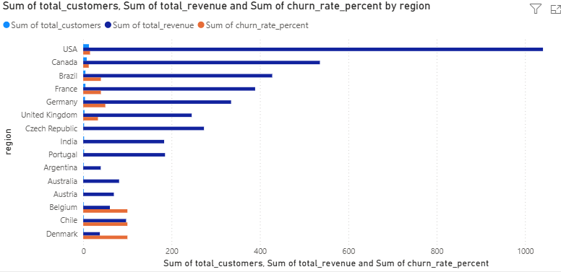

Approach
- The query calculates customer-level metrics (orders, spending, last purchase) and flags churned customers based on a 6-month inactivity window.
- It then aggregates these metrics by billing country, producing a regional summary of:
  - Total customers
  - Total revenue
  - Average order value (AOV)
  - Churn rate (%)

Insights
- USA Leads in Revenue but Shows High Churn With 13 customers and over $1,000 in revenue, the USA is the top-performing region. However, its churn rate of 15.38% suggests retention challenges—possibly due to market saturation or competition.
- Brazil Shows High Churn Despite Moderate Revenue Brazil has a churn rate of 40%, the highest among top-revenue regions. This may reflect economic volatility, inconsistent engagement, or pricing sensitivity.
- Stable European Markets with Low Churn Countries like France, Germany, and Czech Republic show 0% churn and solid AOVs (e.g., Czech Rep at 9.13), indicating loyal customer bases and effective retention.

Recommendations:
- Targeted Retention Campaigns in High-Churn Regions Focus on re-engagement strategies in Brazil and the USA—loyalty programs, personalized offers, or subscription models could reduce churn.
- Leverage High-AOV Regions for Premium Upselling Czech Republic and Portugal show strong AOVs. Consider introducing premium bundles or exclusive content tailored to these markets.
- Correlate with External Data Overlay this analysis with local economic indicators (e.g., GDP, inflation, internet penetration) and demographics (age, income) to refine regional strategies.

6. Customer Risk Profiling: Based on customer profiles (age, gender, location, purchase history), which customer segments are more likely to churn or pose a higher risk of reduced spending? What factors contribute to this risk?
Ans.:- To identify customer segments with a higher likelihood of churn or reduced spending based on purchase history, location, and support interactions.
Query:
WITH recent_invoices AS (
SELECT
customer_id,
MAX(invoice_date) AS last_purchase_date,
COUNT(*) AS total_invoices,
SUM(total) AS total_spent
FROM invoice
GROUP BY customer_id
),
invoice_trend AS (
SELECT
ri.customer_id,
ri.last_purchase_date,
ri.total_invoices,
ri.total_spent,
c.city,
c.country,
c.support_rep_id,
CASE
WHEN ri.total_invoices = 1 THEN 'One-time Buyer'
WHEN ri.total_spent < 50 THEN 'Low Spender'
WHEN ri.last_purchase_date < DATE_SUB(NOW(), INTERVAL 6 MONTH) THEN 'Inactive'
ELSE 'Active'
END AS risk_segment

FROM recent_invoices ri
JOIN customer c ON ri.customer_id = c.customer_id
)
SELECT
customer_id,
city,
country,
support_rep_id,
total_invoices,
total_spent,
last_purchase_date,
risk_segment
FROM invoice_trend
WHERE risk_segment IN ('One-time Buyer', 'Low Spender', 'Inactive')
ORDER BY last_purchase_date ASC;
Output is :( give some output for example)
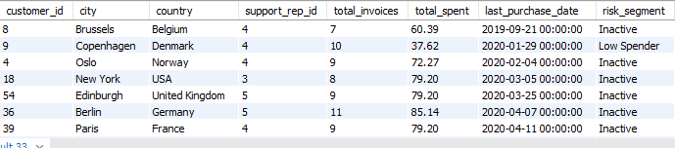
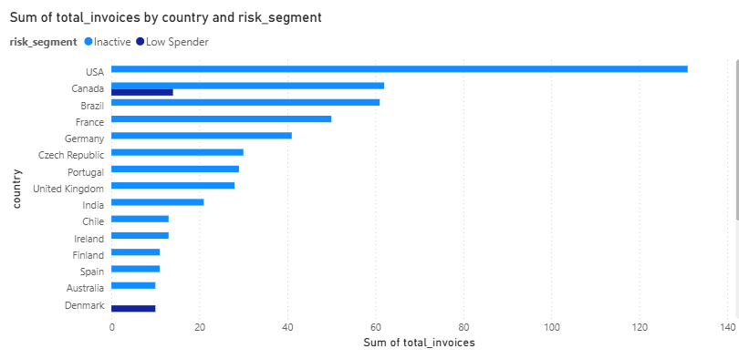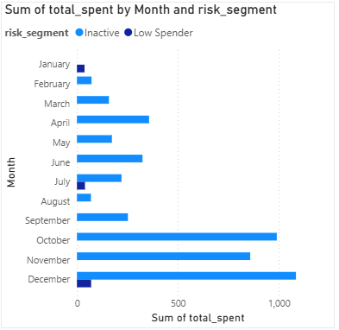

Approach
- The query segments customers based on purchase history:
  - One-time Buyer: Only 1 invoice
  - Low Spender: Total spend < $50
  - Inactive: No purchase in the last 6 months
- It joins this with customer location and support rep data to enrich the profile.

Insights
- High Inactivity Across Regions Most customers in the output fall under the Inactive segment, even with moderate invoice counts and spending. This suggests a drop-off in engagement despite prior activity.
- Low Spenders Are Still Active Customers like the one from Copenhagen (Denmark) are labeled Low Spender but have 10 invoices, indicating consistent but low-value purchases—ideal for upselling or bundling strategies.
- Geographic Risk Clusters Cities like Berlin, Paris, New York, and Edinburgh show multiple inactive customers. These may represent regions with declining engagement or saturated markets.

Recommendations
- Reactivation Campaigns for Inactive Segments Target inactive customers with personalized offers, loyalty incentives, or re-engagement emails. Prioritize cities with multiple inactive users.
- Upsell Opportunities for Low Spenders Introduce tiered pricing, bundles, or exclusive content to increase spend among consistent but low-value buyers.
- Support Rep Performance Review Analyze churn and risk segments by support_rep_id to identify reps managing high-risk customers. This can guide training or reassignment strategies.

7. Customer Lifetime Value Modeling: How can you leverage customer data (tenure, purchase history, engagement) to predict the lifetime value of different customer segments? This could inform targeted marketing and loyalty program strategies. Can you observe any common characteristics or purchase patterns among customers who have stopped purchasing?
Ans.:- Query :
SELECT
customer_id,
MIN(invoice_date) AS first_purchase,
MAX(invoice_date) AS last_purchase,
COUNT(*) AS purchase_count,
SUM(total) AS lifetime_value,
DATEDIFF(MAX(invoice_date), MIN(invoice_date)) AS tenure_days
FROM invoice
GROUP BY customer_id;
Output is :
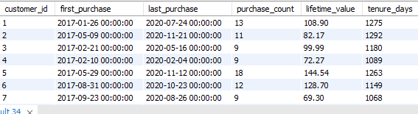

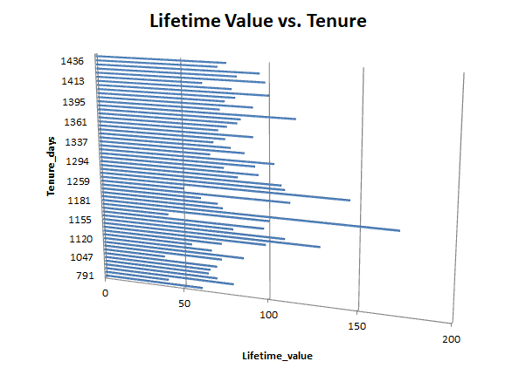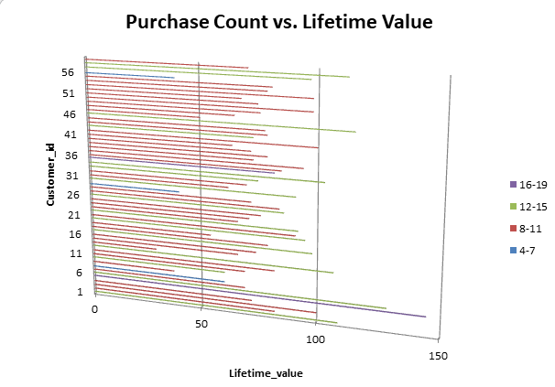

Approach
- You're calculating CLV using:
  - purchase_count: frequency of transactions
  - lifetime_value: total revenue per customer
  - tenure_days: duration between first and last purchase
- This gives a behavioral snapshot of each customer’s value and engagement span.

Insights
- Long Tenure ≠ High Value Some customers (e.g., ID 6) have long tenure (~1068 days) but relatively low lifetime value (~$69). This suggests consistent but low-spending behavior—ideal for upsell strategies.
- High Value Linked to High Frequency Customer ID 5 has the highest purchase_count (18) and highest lifetime_value ($144.54), indicating that frequency is a stronger driver of value than tenure alone.
- Recent Drop-Offs Customers with no purchases after mid-2020 (e.g., ID 3, 5) may be at risk of churn. Their last purchase dates can help flag segments for reactivation campaigns.

Recommendations
- Segment by Value and Tenure Create clusters like:
  - High Value, Long Tenure → Loyalty program candidates
  - Low Value, Long Tenure → Upsell targets
  - High Value, Short Tenure → Retention priority
- Predictive Modeling Use regression or machine learning to predict future CLV based on:
  - Recency, Frequency, Monetary (RFM) metrics
  - Engagement signals (e.g., support interactions, email opens)
- Trigger-Based Marketing Set up automated campaigns based on:
  - Drop in purchase frequency
  - Approaching churn thresholds (e.g., 180 days since last purchase)

8. If data on promotional campaigns (discounts, events, email marketing) is available, how could you measure their impact on customer acquisition, retention, and overall sales?
Ans.:- To measure the impact of promotional campaigns on customer acquisition, retention, and overall sales in the Chinook database, we can analyze changes in key customer and sales metrics before, during, and after the campaign period.
Even though the existing Chinook schema doesn’t include a direct “campaign” table, we can infer the impact by linking invoice, customer, and invoice_line data with campaign timeframes or tagged discounts.
Step to solve question:
a. Identify new customers who made their first purchase during or immediately after the campaign.
b. Query: Find customers whose first invoice_date falls within the campaign period.
c. Compare the number of new customers before and after the campaign.
e. Analyze how many existing customers made repeat purchases after the campaign.
f. Measure the percentage of returning customers by checking those with multiple invoices over time.
g. Compare total invoice revenue (total column) before and after the campaign period.
h. Group data by month or country to see which region or time frame responded best.
i. Using invoice_line, track, and genre, analyze which music genres or albums sold more during campaigns.
If campaigns include channels like email marketing or discounts, you could:
- Tag invoices with campaign codes.
- Compare metrics such as:
  - Average order value (AOV)
  - Revenue per customer
  - Conversion rate (number of purchases ÷ number of emails sent)
Query:
WITH FirstPurchase AS (
SELECT
customer_id,
MIN(invoice_date) AS first_purchase_date
FROM invoice
GROUP BY customer_id
),
CustomerGroups AS (
SELECT
f.customer_id,
CASE
WHEN f.first_purchase_date < '2022-01-01' THEN 'Existing Before Campaign'
WHEN f.first_purchase_date BETWEEN '2022-01-01' AND '2022-03-31' THEN 'Acquired During Campaign'
ELSE 'Acquired After Campaign'
END AS customer_status
FROM FirstPurchase f
),
SalesSummary AS (
SELECT
CASE
WHEN invoice_date < '2022-01-01' THEN 'Before Campaign'
WHEN invoice_date BETWEEN '2022-01-01' AND '2022-03-31' THEN 'During Campaign'
ELSE 'After Campaign'
END AS period,
SUM(total) AS total_sales
FROM invoice
GROUP BY period
),
RetentionStats AS (
SELECT
c.customer_id,
COUNT(i.invoice_id) AS purchase_count
FROM customer c
JOIN invoice i ON c.customer_id = i.customer_id
GROUP BY c.customer_id
HAVING COUNT(i.invoice_id) > 1
)
SELECT
(SELECT COUNT(DISTINCT customer_id)
FROM CustomerGroups WHERE customer_status = 'Acquired During Campaign') AS New_Customers_During_Campaign,

(SELECT COUNT(customer_id) FROM RetentionStats) AS Retained_Customers,

(SELECT total_sales FROM SalesSummary WHERE period = 'Before Campaign') AS Sales_Before_Campaign,
(SELECT total_sales FROM SalesSummary WHERE period = 'During Campaign') AS Sales_During_Campaign,
(SELECT total_sales FROM SalesSummary WHERE period = 'After Campaign') AS Sales_After_Campaign;
Output :
Conclusion:
By combining invoice, customer, and invoice_line data, we can:
- Track new vs. returning customers (acquisition & retention),
- Analyze sales performance before and after campaigns, and
- Identify which genres, artists, or regions saw the most growth.
This data-driven approach helps determine which promotional strategies are most effective in boosting customer loyalty and overall revenue.
9.How would you approach this problem, if the objective and subjective questions weren't given?
Ans.:- If the questions were not provided, I would approach the Chinook Music Store analysis systematically by following a data analytics problem-solving process.
a. Understand the Business Context
• The Chinook database represents a digital music store selling tracks, albums, and playlists.
• I would identify possible business goals, such as:
- Increasing sales and customer retention
- Finding top-selling genres or artists
- Understanding customer purchasing behaviour by country or employee
b. Explore and Understand the Data
• Review table structures and relationships (using schema or ER diagram).
• Identify key tables:
- customer, invoice, invoice_line → for sales and customer data
- track, album, artist, genre → for music catalog data
- employee → for support/sales team performance
• Check for data quality issues (missing values, duplicates, etc.).
c. Create Questions for Analysis
I would create my own questions to drive analysis, such as:
- What are the top-selling genres and artists?
- Which countries contribute most to sales?
- How many new vs. returning customers are there?
- What is the average spending per customer?
- Which employees manage the highest-revenue customers?
d. Write Queries for that Questions
Use SQL to extract insights from the data:
- Descriptive queries → totals, averages, counts.
- Analytical queries → grouping, joining, filtering, ranking.
- CTEs and subqueries for modular and reusable analysis.

e. Interpret and Communicate Results for visualization
- Convert SQL outputs into clear business insights.
- Use charts or dashboards (Excel / Power BI) to visualize:
  - Revenue by country
  - Top genres or customers
  - Monthly sales trends
10.How can you alter the "Albums" table to add a new column named "ReleaseYear" of type INTEGER to store the release year of each album?
Ans.:- To add a new column to an existing table, we use the ALTER TABLE statement with the ADD COLUMN clause.
Query:
USE Chinook;
ALTER TABLE album
ADD COLUMN ReleaseYear INTEGER;
Explanation:
Use Chinook – it means we select or find or add data in this database.
Alter Table album – it selects album table to modify
Add Column ReleaseYear Integer - adds a new column named ReleaseYear to store the release year as an integer value (e.g., 2008, 2012)

11. Chinook is interested in understanding the purchasing behaviour of customers based on their geographical location. They want to know the average total amount spent by customers from each country, along with the number of customers and the average number of tracks purchased per customer. Write an SQL query to provide this information.
Ans.:-
Query:
WITH CustomerStats AS (
SELECT
c.customer_id,
c.country,
SUM(i.total) AS total_spent,
SUM(il.quantity) AS total_tracks_purchased
FROM customer c
JOIN invoice i ON c.customer_id = i.customer_id
JOIN invoice_line il ON i.invoice_id = il.invoice_id
GROUP BY c.customer_id, c.country
)
SELECT
country,
COUNT(customer_id) AS Number_of_Customers,
ROUND(AVG(total_spent), 2) AS Avg_Total_Spent_Per_Customer,
ROUND(AVG(total_tracks_purchased), 2) AS Avg_Tracks_Purchased_Per_Customer
FROM CustomerStats
GROUP BY country
ORDER BY Avg_Total_Spent_Per_Customer DESC;
Output:
Country | No_of_Customers | Avg_Total_Spent_Per_Customer | Avg_Tracks_Purchased_Per_Customer
Czech Republic | 2 | 1591.92 | 138
Ireland | 1 | 1433.52 | 116
Spain | 1 | 1076.13 | 99
India | 2 | 943.97 | 92.5
Australia | 1 | 940.5 | 82
Chile | 1 | 912.78 | 98
Portugal | 2 | 877.64 | 93.5
Germany | 4 | 860.31 | 84.5
United Kingdom | 3 | 832.92 | 82.67
Hungary | 1 | 830.61 | 79
Brazil | 5 | 811.8 | 86.4
USA | 13 | 800.45 | 80.85
France | 5 | 794.57 | 78.6
Sweden | 1 | 754.38 | 76
Poland | 1 | 690.03 | 77
Canada | 8 | 686.19 | 67.63
Finland | 1 | 685.08 | 80
Norway | 1 | 664.29 | 73
Austria | 1 | 649.44 | 70
Belgium | 1 | 567.27 | 61
Netherlands | 1 | 544.5 | 66
Italy | 1 | 468.27 | 51
Argentina | 1 | 396 | 40
Denmark | 1 | 196.02 | 38

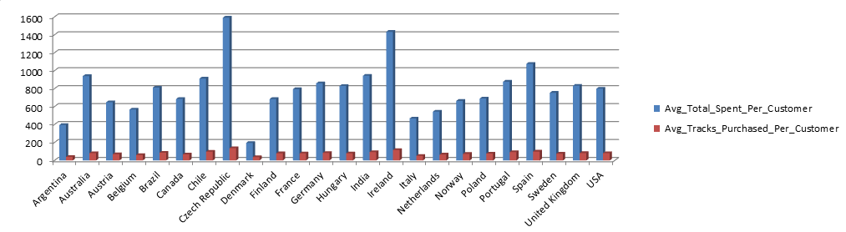

Approach
- The query uses a two-level aggregation:
  - First, it calculates total spending and track quantity per customer.
  - Then, it aggregates by country to compute:
    - Number of customers
    - Average total spent per customer

Insights
- High-Spending Regions Aren’t Always High-Volume Countries like Germany and Czech Republic have fewer customers but higher average spend, suggesting strong monetization per user.
- Track Consumption Doesn’t Always Match Spending Some countries (e.g., India) show high track purchases but moderate spending, which may indicate preference for lower-priced or bundled content.
- USA Has Broad Reach but Lower Spend Per Customer Despite having more customers, the USA’s average spend is mid-tier, pointing to a need for better monetization strategies

Recommendations
- Premium Upsell in High-AOV Markets Target countries like Germany and Czech Republic with premium bundles, exclusive content, or loyalty rewards—they’re already spending more.
- Volume-Based Offers in High-Track Regions In countries like India and Portugal, introduce bulk purchase discounts or subscription models to capitalize on high track consumption.
- Customer Growth vs. Value Strategy For countries with many customers but low spend (e.g., USA, Brazil), focus on increasing average order value through cross-selling or personalized recommendations.

